Lab 6

Doubly Linked List

Objective:
The objective of this lab is to implement Doubly Linked List.

Introduction:
A doubly linked list is a linked list in which every node has a next pointer and a back pointer. In other words, every node contains the address of the next node ( last node points to null as next node), and every node contains the address of the previous node (first node points to null as the previous node).

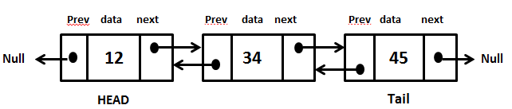

Doubly Linked List
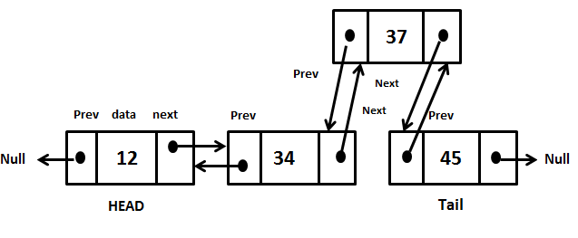

Insertion

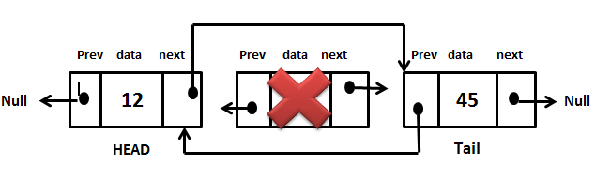
Deletion

Exercise: Implement a doubly linked list.
Design, Develop and Implement a menu driven Program in C++ for the following operations on Doubly Linked List (DLL) of Students’ ID.
a. Create a DLL of N Students’ ID by using end insertion.
b. Display the status of DLL and count the number of nodes in it
c. Perform Insertion and Deletion at End of DLL
d. Perform Insertion and Deletion at Front of DLL
e. Perform Insertion and Deletion in the middle of DLL
f. Exit

